27 January 2026

New chapter: our journey together begins
We give all glory and thanks to God for His faithfulness, protection, and clear direction. By His grace, we have safely relocated to Cape Town in response to a new calling He has placed upon our lives and work.
We departed from Durban, KwaZulu-Natal on the 2nd of January and, by God’s mercy, arrived safely in Cape Town the following day. The journey was smooth, and we experienced His covering throughout. This relocation represents growth, renewed vision, and greater opportunity to fulfil our calling. We are deeply grateful for the prayers, encouragement, and support that have carried us to this point, and we look forward to what God will accomplish in this new season.
Update on my family
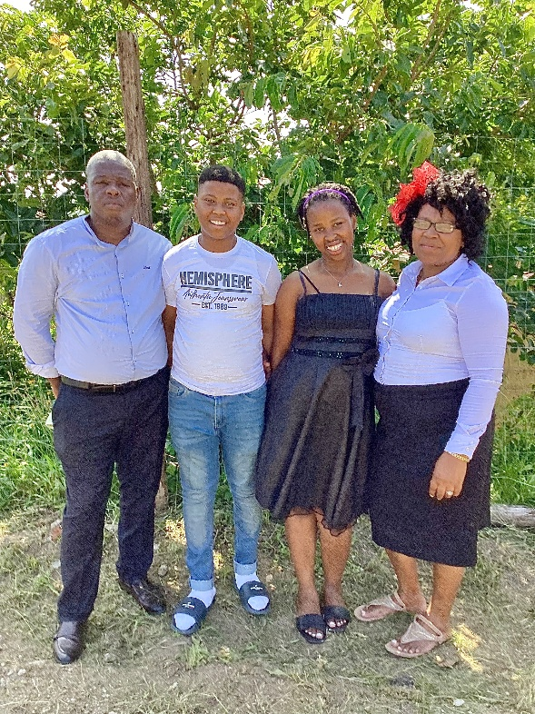
My wife, Sindy, returned to KwaZulu-Natal to assist our daughter, Slindokuhle, who remained behind while awaiting her Grade 12 results. We are grateful to God for His faithfulness, as Slindokuhle passed with a Bachelor’s pass and achieved a distinction in Mathematics.
We give thanks to God for this remarkable achievement. By His grace, she has been accepted at the University of KwaZulu-Natal, Howard College, where she will be pursuing a Bachelor of Arts degree.
We truly serve a marvellous God, and we are deeply thankful for His continued favour and guidance over our family.

Ministry update
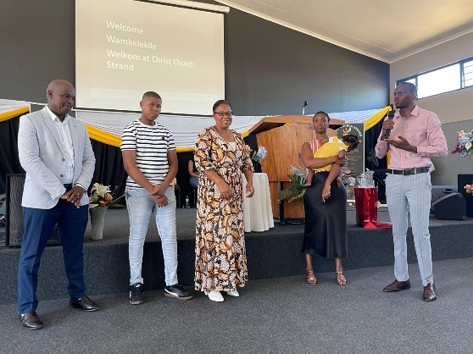
On the 4th of January, we had our first Sunday at Christ Church Strand, where we were warmly welcomed by Bishop Makapela, Reverend Muyambo, their wives, and the entire congregation. We are truly excited and grateful to be part of the Christ Church Strand family.

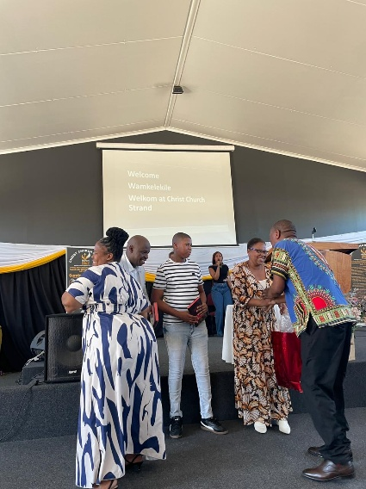
We thank God that most of the church services have now commenced. The English services officially began on the 18th of January, while the Xhosa service has remained active, even through December. It is encouraging to see the church continuing its ministry without interruption, and we are humbled to be joining in this vibrant community of faith.

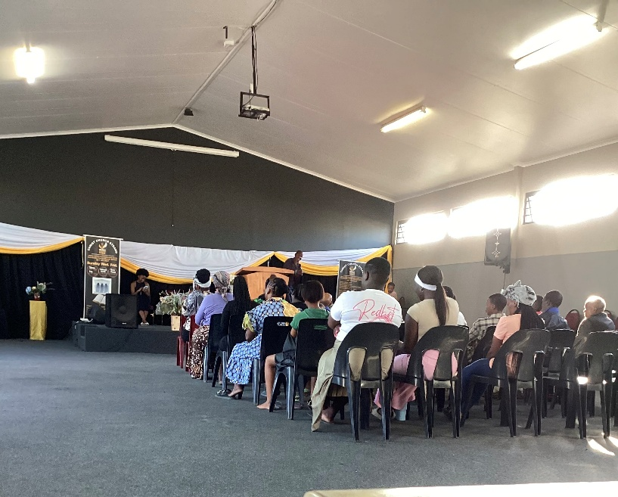
We are currently observing a week of prayer and fasting from 26–30 January, during which we are praying for the salvation of people in the Strand community.
Next week, we will hold another week of prayer and fasting in Khayamandi, Stellenbosch. Please pray that God will sustain us and grant us strength as we continue this work.

Upcoming Ministry Projects and Gratitude
We are excited to announce that our additional ministry initiatives — including the Soup Kitchen, Sewing Project, House Church, and Kids Ministry — will begin in the first week of February. We pray that God will continue to save and transform lives through these projects.
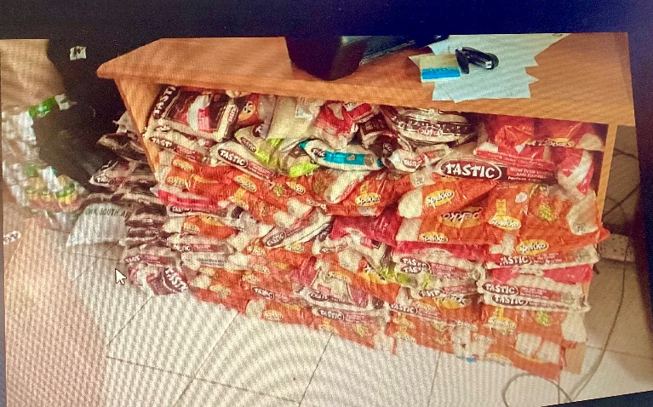
We are deeply thankful to God for the generous support we have already received, particularly the donations for the Soup Kitchen from St. Stephen’s Church and other kind-hearted donors. Your contributions are already making a tangible difference.
Christ Church Strand is in a community where many families face poverty and unemployment. For many in this area, the Soup Kitchen provides essential support, meeting both physical and spiritual needs. We are grateful to partner with God in serving this community and bringing hope and practical assistance to those who need it most.
The Khayamandi congregation has been attending Christ Church every Sunday, and they meet in Stellenbosch only for Wednesday services. Last Sunday was their final Sunday with us. However, we will continue to meet once a month for a combined Holy Communion service.
We held a commissioning service to send them out to preach the Word in Khayamandi “As the Word of God says in Matthew: “Therefore go and make disciples of all nations, baptizing them in the name of the Father and of the Son and of the Holy Spirit.”

Thanksgiving
- We thank God for the successful commissioning service and for sending the Khayamandi congregation to preach the Word in their community.
- We thank God for His presence and guidance during the week of prayer and fasting held from 26–30 January.
Prayer Requests
- Pray for the salvation of people in the Strand community.
- Pray for the upcoming week of prayer and fasting in Khayamandi, Stellenbosch.
- Pray that God will sustain us, give us strength, and renew us as we continue His work.
- Pray for spiritual growth, protection, and boldness as we share the Gospel.

